Dusky and Common dolphin abundance in San Matias Gulf by DSM
Ver Miller et al 2013. Methods in Ecology and Evolution 2013, 4, 1001–1010 doi: 10.1111/2041-210X.12105
Script: scriptVana5
library(dsm)
library(ggplot2)
library(rgdal)
library(maptools)
library(plyr)
library(Distance)
library(mrds)
library(tweedie)

#distdata holds the distance sampling data that will be used to fit the detection function.
#segdata holds the segment data: the transects have already been "chopped" into segments.
#obsdata holds the observations which have already been aggregated to the segments and
#preddata holds the prediction grid (which includes all the necessary covariates).

##los archivos a usar para ajustar la funcion de deteccion se llaman distdata_dd_todos.csv y distadata_lo_todos.csv
##estos archivos tienen todos los datos sin truncar y con las medidas exactas
###la primera parte es para obtener la función de detección que luego
#se incorpora en los GAMs,

COMMON DOLPHIN
####Detection function
####Exploratory data analysis
######distdata_dd_todos2.csv tiene un dato de menos respecto del archivo distdata_dd_todos.csv, que corresponde a una observación hecha con Beaufort 5 eliminada directamente en el archivo, esto se hizo porque no ajustaba la Hazard rate
distdata_dd<-read.csv("distdata_dd_todos2.csv",sep=";")
# histograms distances whole sample
windows();par(mfrow = c(1, 1))
hist(distdata_dd$distance, main = "Common dolphin n=717", breaks= 80, xlab = "Distance (m)")
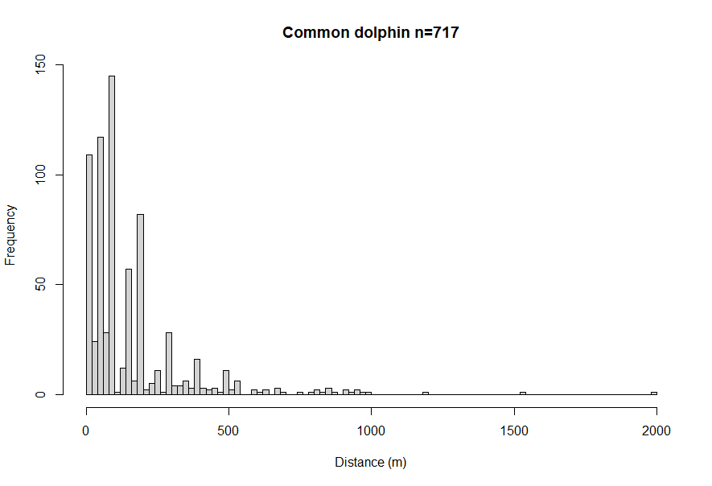
###en el grafico se puede ver el redondeo en clases de a 100
###ademas posiblemente la distancia 0 esta sobrerepresentada, posiblemente por acercamiento de los animales
#####Segun Bucckland et al 2001 sections 4.5 y 7.4.1.2, agrupar los datos de distancia son una solución para ambos problemas
###por lo tanto se van a tratar como datos de distancias redondeadas en lugar de exactas, esto se hara incluyendo la opcion "cutpoints"

#####exploratory analysis of covariates to be added to the detection function
######este análisis se hace con todos los datos sin truncar y sin redondear
windows();par(mfrow = c(2, 2))
#histogram group size
hist(distdata_dd$size, breaks = 50, main="", xlab = "Cluster size")
# plots of distance vs. cluster size
plot(distdata_dd$distance, distdata_dd$size, main = "", xlab = "Distance (m)",
ylab = "Group size", pch = 19, cex = 0.5, col = rgb(0.1, 0.1, 0.74, 0.7))
# lm fit
l.dat <- data.frame(distance = seq(0, 8000, len = 1000))
lo <- lm(size ~ distance, data = distdata_dd)
lines(l.dat$distance, as.vector(predict(lo, l.dat)))
#beaufort
plot(distdata_dd$distance, distdata_dd$beaufort, main = "", xlab = "Distance (m)",
ylab = "Beaufort sea state", pch = 19, cex = 0.5, col = rgb(0.1, 0.1, 0.74, 0.7))
#Vessel type
plot(distdata_dd$distance, distdata_dd$ship, main = "", xlab = "Distance (m)",
ylab = "vessel type", pch = 19, cex = 0.5, col = rgb(0.1, 0.1, 0.74, 0.7))

#####en los graficos se observa una tendencia a mayor número de observaciones a mayor distancia en el Vesseltype #1, particularmente las observaciones entre 500 y 1000 mts
#####tambien se observa grupos mas grandes a mayor distancia

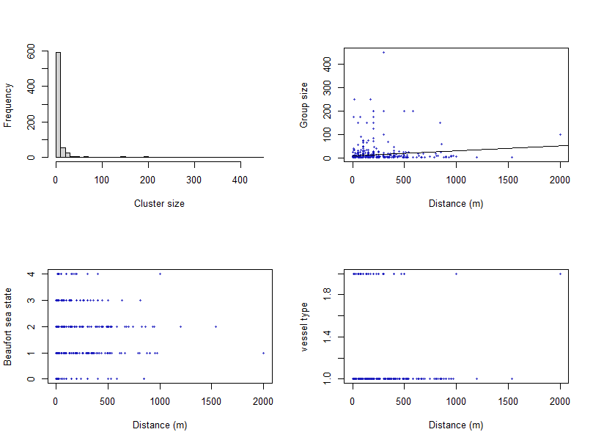

###Estimating detection function
###en este script, el truncado es a 400 mts, lo cual elimina aprox 8% de los datos, 56 observaciones en el caso de delphinus sobre un total de 717
####funciones de detección usando mismo archivo que en analisis exploratorio, truncando a 400 y usando cutpoints para tratar las distancias exactas como binned data
cutpoints400<-c(0,100,200,300,400)
##Hazard rate, con diferentes terminos de ajuste
detfc.hr.nulldd_400bin2<-ds(distdata_dd, key="hr", cutpoints=cutpoints400, truncation=400)
detfc.hr.nulldd_400bin1<-ds(distdata_dd, key="hr", cutpoints=cutpoints400, truncation=400, nadj=1)
detfc.hr.nulldd_400bin0<-ds(distdata_dd, key="hr", cutpoints=cutpoints400, truncation=400, adjustment = NULL)
##Half normal con diferentes terminos de ajuste
detfc.hn.nulldd_400bin2<-ds(distdata_dd, key="hn", cutpoints= cutpoints400, truncation = 400)
detfc.hn.nulldd_400bin1<-ds(distdata_dd, key="hn", cutpoints= cutpoints400, truncation = 400, nadj=1)
detfc.hn.nulldd_400bin0<-ds(distdata_dd, key="hn", cutpoints= cutpoints400, truncation = 400, adjustment = NULL)

##Uniform,
detfc.unif.nulldd_400bin<-ds(distdata_dd, key="unif", cutpoints = cutpoints400, truncation=400)

##Seleccion de funcion de deteccion
Para seleccionar el modelo de function de deteccion se miran los graficos, esperndo una function con un hombro, el AIC, y bondad de ajuste
windows();par(mfrow = c(2, 3))
plot(detfc.unif.nulldd_400bin, main="Uniform")
plot(detfc.hn.nulldd_400bin0, main="half normal 0")
plot(detfc.hn.nulldd_400bin1, main="half normal 1")
plot(detfc.hn.nulldd_400bin2, main="half normal 2")
plot(detfc.hr.nulldd_400bin0, main="hazard rate 0")
plot(detfc.hr.nulldd_400bin1, main="hazard rate 1")

ddf.gof(detfc.unif.nulldd_400bin)
ddf.gof(detfc.hn.nulldd_400bin0)
ddf.gof(detfc.hn.nulldd_400bin1)
ddf.gof(detfc.hn.nulldd_400bin2)
ddf.gof(detfc.hr.nulldd_400bin0)
ddf.gof(detfc.hr.nulldd_400bin1)

AIC(detfc.unif.nulldd_400bin, detfc.hn.nulldd_400bin0, detfc.hn.nulldd_400bin1,
detfc.hn.nulldd_400bin2, detfc.hr.nulldd_400bin1, detfc.hr.nulldd_400bin0)

#####Tabla resumen
knitr::kable(summarize_ds_models(detfc.hn.nulldd_400bin1, detfc.hn.nulldd_400bin2,detfc.hr.nulldd_400bin1, detfc.hr.nulldd_400bin0), digits=3, caption="K+A Model comparison table for common dolphins data")

###Selecciono hazard rate sin terminos de ajuste

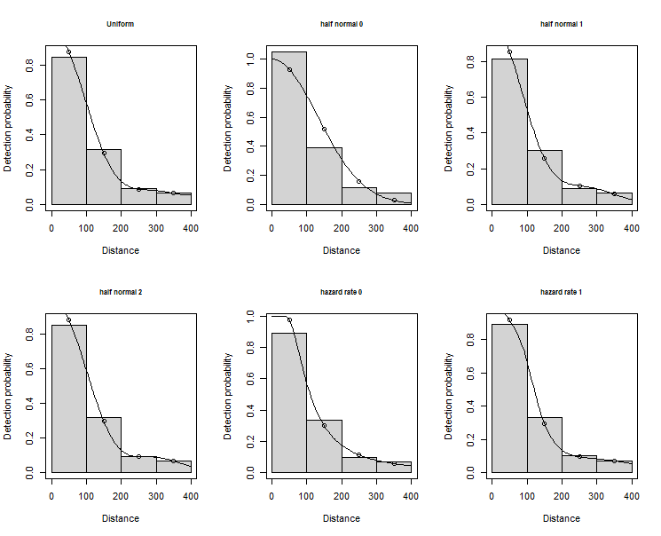

df AIC
detfc.hn.nulldd_400bin0 1 1330.159
detfc.hn.nulldd_400bin1 2 1282.630
detfc.hn.nulldd_400bin2 3 1282.240
detfc.unif.nulldd_400bin 3 1282.202
detfc.hr.nulldd_400bin1 3 1282.202
detfc.hr.nulldd_400bin0 2 1282.786
Table: K+A Model comparison table for common dolphins data

| |Model |Key function |Formula | $\chi^2$ $p$-value| $\hat{P_a}$| se($\hat{P_a}$)| $\Delta$AIC|
|:--|:--------------------------------------|:-----------------------------------------------------|:-------|------------------:|-----------:|---------------:|-----------:|
|3 |\texttt{detfc.hr.nulldd\char`_400bin1} |Hazard-rate with cosine adjustment term of order 2 |~1 | NA| 0.348| 0.016| 0.000|
|2 |\texttt{detfc.hn.nulldd\char`_400bin2} |Half-normal with cosine adjustment terms of order 2,3 |~1 | NA| 0.333| 0.017| 0.037|
|1 |\texttt{detfc.hn.nulldd\char`_400bin1} |Half-normal with cosine adjustment term of order 2 |~1 | 0.123| 0.318| 0.012| 0.428|
|4 |\texttt{detfc.hr.nulldd\char`_400bin0} |Hazard-rate |~1 | 0.110| 0.347| 0.024| 0.583|
>

####agregando covariables ambientales
#ship
#Beaufort
#group size
detfc.hr.dd_400binship <- ds(distdata_dd, truncation= 400, cutpoints = cutpoints400,
formula = ~as.factor(ship), key = "hr", adjustment = NULL)
detfc.hr.dd_400binbeauf <- ds(distdata_dd, truncation= 400, cutpoints = cutpoints400,
formula = ~as.factor(beaufort), key = "hr", adjustment = NULL)
detfc.hr.dd_400binGsize <- ds(distdata_dd, truncation= 400, cutpoints = cutpoints400,
formula = ~size, key = "hr", adjustment = NULL)
detfc.hr.dd_400binbeauf_size <- ds(distdata_dd, truncation= 400, cutpoints = cutpoints400,
formula = ~as.factor(beaufort)+ size, key = "hr", adjustment = NULL)
detfc.hr.dd_400binGsize_ship <- ds(distdata_dd, truncation= 400, cutpoints = cutpoints400,
formula = ~size + as.factor (ship), key = "hr", adjustment = NULL)

df AIC
detfc.hr.nulldd_400bin0 2 1282.786
detfc.hr.dd_400binship 3 1283.737
detfc.hr.dd_400binbeauf 6 1262.060
detfc.hr.dd_400binGsize 3 1276.164
detfc.hr.dd_400binbeauf_size 7 1257.526
detfc.hr.dd_400binGsize_ship 4 1276.930

#####Tabla resumen
knitr::kable(summarize_ds_models(detfc.hr.nulldd_400bin0, detfc.hr.dd_400binGsize,detfc.hr.dd_400binbeauf_size),digits=3,
caption="K+A Model comparison table for common dolphins data")
Table: K+A Model comparison table for common dolphins data

| |Model |Key function |Formula | $\chi^2$ $p$-value| $\hat{P_a}$| se($\hat{P_a}$)| $\Delta$AIC|
|:--|:-------------------------------------------------|:------------|:---------------------------|------------------:|-----------:|---------------:|-----------:|
|3 |\texttt{detfc.hr.dd\char`_400binbeauf\char`_size} |Hazard-rate |~as.factor(beaufort) + size | NA| 0.339| 0.026| 0.000|
|2 |\texttt{detfc.hr.dd\char`_400binGsize} |Hazard-rate |~size | NA| 0.343| 0.025| 18.638|
|1 |\texttt{detfc.hr.nulldd\char`_400bin0} |Hazard-rate |~1 | 0.11| 0.347| 0.024| 25.260|

Funcion de deteccion seleccionada para Common dolphin es
key function Hazard rate without adjustment terms and with beaufort and group size as covariates
detfc.hr.dd_400binbeauf_size

DUSKY DOLPHIN
###Detection function
distdata_lo<- read.csv("distdata_lo_todos.csv",sep=";")
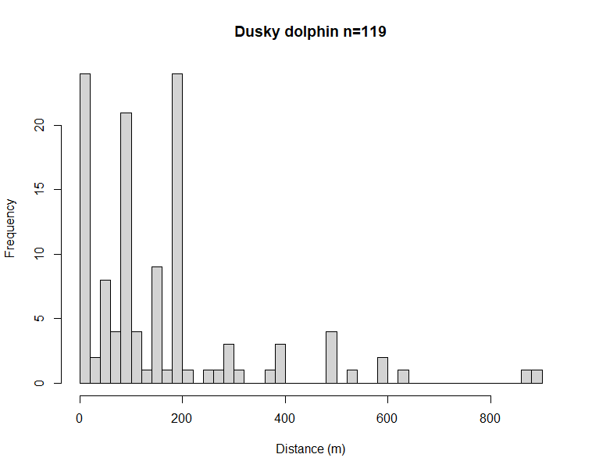
#####exploratory analysis of covariates to be added to the detection function 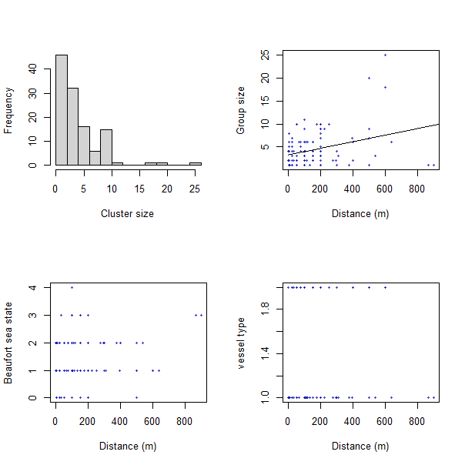
Estimating detection function
####el truncado a 400 mts elimina 10 observaciones sobre 119, representa 8,4% de los datos
Tratando datos como binned y truncado a 400 mts

Table: K+A Model comparison table for dusky dolphins data

| |Model |Key function |Formula | $\chi^2$ $p$-value| $\hat{P_a}$| se($\hat{P_a}$)| $\Delta$AIC|
|:--|:---------------------------------------|:-------------------------------------------------|:-------|------------------:|-----------:|---------------:|-----------:|
|1 |\texttt{detfc.hr.nulllo\char`_400bin} |Hazard-rate |~1 | 0.106| 0.452| 0.042| 0.000|
|3 |\texttt{detfc.unif.nulllo\char`_400bin} |Uniform with cosine adjustment terms of order 1,2 |NA | 0.081| 0.415| 0.012| 0.808|
|2 |\texttt{detfc.hn.nulllo\char`_400bin} |Half-normal |~1 | 0.049| 0.422| 0.029| 1.614|
>

df AIC
detfc.hr.nulllo_400bin 2 224.8406
detfc.hn.nulllo_400bin 1 226.4544
detfc.unif.nulllo_400bin 2 225.6487
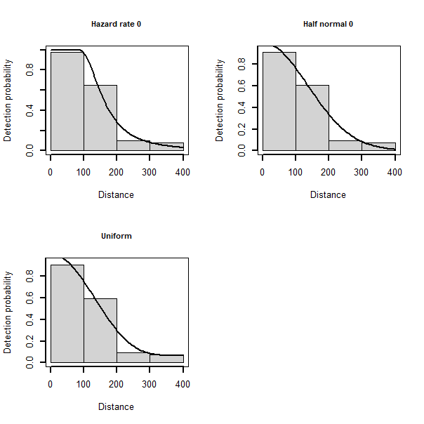
#best model selected for distance data Lagenorhynchus
detfc.hr.nulllo_400bin<-ds(distdata_lo, truncation = max(cutpoints400), key="hr", cutpoints= cutpoints400)

Agregando covariables ambientales ship, beaufort group size
df AIC
detfc.hr.nulllo_400bin 2 224.8406
detfc.hr.lo_400binbeau 6 226.2323
detfc.hr.lo_400binship 3 226.7351
detfc.hr.lo_400binGsize 3 222.9562
Conclusion: modelo Hazard rate con binned data truncado a 400 y sin covariables ambientales

DSM models for dusky dolphins

Family= negative binomial

dsm.lo.full <- dsm(count~s(x,y,k=20)+
s(dist.coast, k = 20)+
s(slope, k = 20) +
s(depth, k = 20)+
s(sst, k = 20)+
s(clo, k =20)+
s(grad, k = 20)+
s(dist.up, k = 20)+
s(Ano, k = 10)+
s(Mes_n, k = 10),
detfc.lo, segdata, obsdata_lo, family=nb(), method="REML")
Family: Negative Binomial(0.012)
Link function: log

Formula:
count ~ s(x, y, k = 20) + s(dist.coast, k = 20) + s(slope, k = 20) +
s(depth, k = 20) + s(sst, k = 20) + s(clo, k = 20) + s(grad,
k = 20) + s(dist.up, k = 20) + s(Ano, k = 10) + s(Mes_n,
k = 10) + offset(off.set)

Parametric coefficients:
Estimate Std. Error z value Pr(>|z|)
(Intercept) -19.912 1.417 -14.05 <2e-16 ***
---
Signif. codes: 0 ‘***’ 0.001 ‘**’ 0.01 ‘*’ 0.05 ‘.’ 0.1 ‘ ’ 1

Approximate significance of smooth terms:
edf Ref.df Chi.sq p-value
s(x,y) 2.006 2.011 5.139 0.0770 .
s(dist.coast) 1.000 1.000 4.473 0.0344 *
s(slope) 1.437 1.750 0.437 0.6706
s(depth) 3.135 4.016 9.054 0.0604 .
s(sst) 5.477 6.879 49.777 <2e-16 ***
s(clo) 1.000 1.000 0.150 0.6983
s(grad) 2.425 3.071 3.177 0.3323
s(dist.up) 1.000 1.000 6.196 0.0128 *
s(Ano) 5.333 6.444 11.744 0.0870 .
s(Mes_n) 1.000 1.000 38.150 <2e-16 ***
---
Signif. codes: 0 ‘***’ 0.001 ‘**’ 0.01 ‘*’ 0.05 ‘.’ 0.1 ‘ ’ 1

R-sq.(adj) = -0.267 Deviance explained = 52.7%
-REML = 537.05 Scale est. = 1 n = 6288

Segun test de concurvity(dsm.lo.full)
Depth y dist coast correlacionadas
Sst y mes correlacionadas

df AIC GCV dev.exp
dsm.lo.full(todos con smooth) 30.17169 1091.511 537.05 52.7
dsm.lo.full2(distcoast, clo, distup y mes como lineales 30.17379 1091.513 556.02 52.7
dsm.lo.distcoast_slope_sst_clo_grad_distup_Ano_Mes 26.25199 1095.114 559.5 50
dsm.lo.depth_slope_sst_clo_grad_distup_Ano_Mes 28.03638 1092.027 549.37 51.5
dsm.lo.depth_slope_clo_grad_distup_Ano_Mes 15.92741 1136.693 569.32 32.6
dsm.lo.depth_slope_sst_grad_distup_Ano_Mes 27.03658 1090.244 548.95 51.4
dsm.lo.depth_slope_sst_clo_distup_Ano_Mes 25.70996 1095.215 552.97 49.6
dsm.lo.depth_slope_sst_clo_grad_distup_Ano 22.57244 1118.670 560.32 42.1
dsm.lo.depth_slope_sst_grad_distup_Mes 29.26952 1100.510 551.55 50.2
dsm.lo.depth_slope_sst_distup_Ano_Mes 35.50002 1094.074 552.97 54.4
dsm.lo.depth_sst_grad_distup_Mes 20.54341 1094.957 551.42 47.1
dsm.lo.slope_sst_distup_Mes 25.53159 1107.004 559.23 46.7
dsm.nb.lo_xy_s_sst_dup_2_m(nadia) 25.09501 1106.284 557.3 46.6

